**Pasifika Cultural**

The picturesque island nation of New Zealand has a deep-rooted Māori culture that’s been influenced, over the years, by many other cultures. As New Zealand was once colonised by the British, you’ll see European undertones in the lifestyles of the locals. Being a small country with a population of just 5 million people has helped the people to build and maintain a tight-knit community, which contributes to the further preservation of the culture.

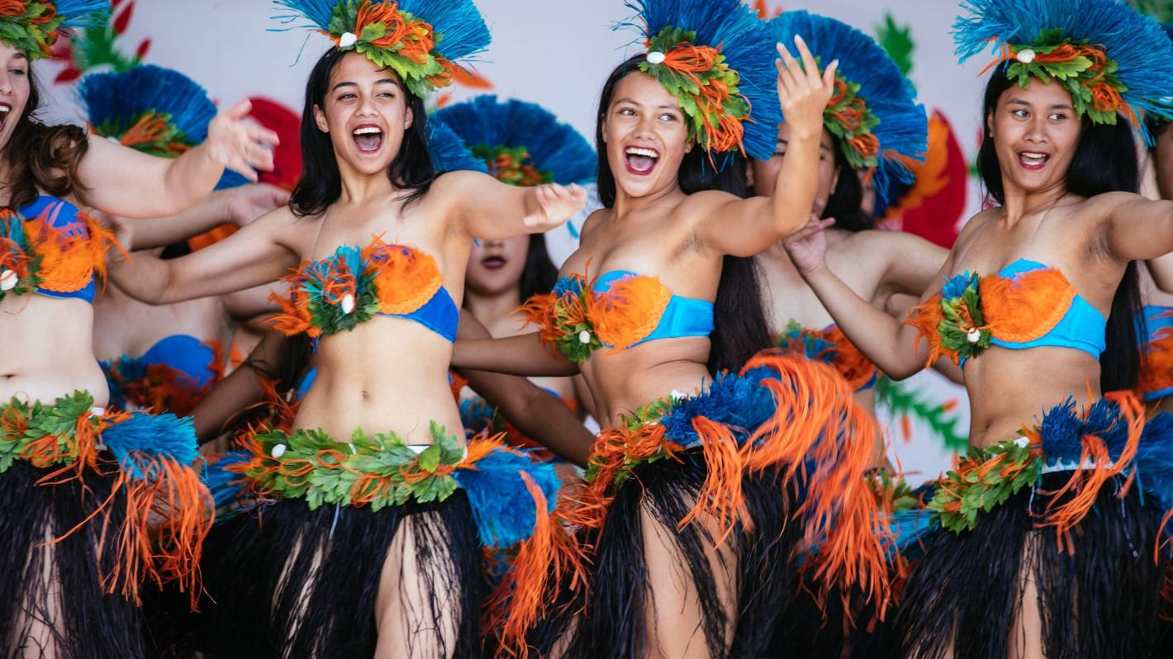

The Pasifika Cultural Festival takes places in the first week of March every year. A festival that strongly focuses on New Zealand’s Pacific Island communities, this festival is one of the best and the biggest ones in the country. Here, you get to experience the different cultures from Tahiti, Fiji, Hawaii, Aotearoa, Kiribati, Samoa, Tonga and so on, through the multiple dance, art, music and food events spread over two days. With more than 80,000 people visiting, it is the biggest representation of the cultures of the said communities!